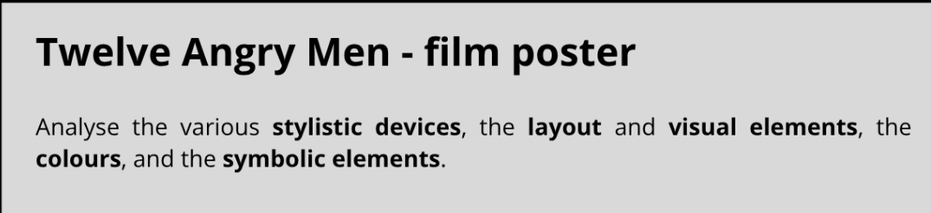
The poster is really colorfull, the dominant color is yellow and blue wich are next to each other in the color wheel so almost complementary they make a really good contrast, it’s kind of empty representing only a knife, a guy and some writing
the layout is very unique usually poster are full of foreshadowing events of the movie this one only has two elements
one of the guys on top of the poster is looking the knife in a weird way and the other men looks like they are mad and protesting about something
the drawings like the knifes and the mens on top are drawn simply like on tarot cards with just black and a colored background
the colors are the primary colors

stylistic choices : the poster is cut in half by a giant knifeupon the head of a man that might represente the damocles sword that same knife is cutting in half a word in the poster. The poster is oddly empty compared to usual movie poster that are trying the include the most story related elements

The layout is cut in three parts, the top part that is in all blue with 11 men that look very mad and are protesting something exept for one that seem to be looking either at the knife, one of the men or just lost in his toughts, the second part i

